





// C++ code

int pir, buzz; float temp; void setup()

{

pir = 3;

buzz = 12; pinMode(pir, INPUT); pinMode(buzz, OUTPUT); Serial.begin(9600);

}

void loop()

{

//Motion Monitoring

int motion = digitalRead(pir); if(motion == 1)

{

tone(buzz,50);

Serial.println("Motion Status: Detected"); delay(50);

}

else

{

noTone(buzz);

Serial.println("Motion Status: Not Detected");

}

//Temperature Measurement float data = analogRead(A4);

float temp =(((data/1024.0)*5)*100);

Serial.print("Temperature is:"); Serial.println(temp); if(temp>60)

{

tone(buzz,200,200); delay(500);

}

else{

noTone(buzz);

}

}

**OUTPUT:**

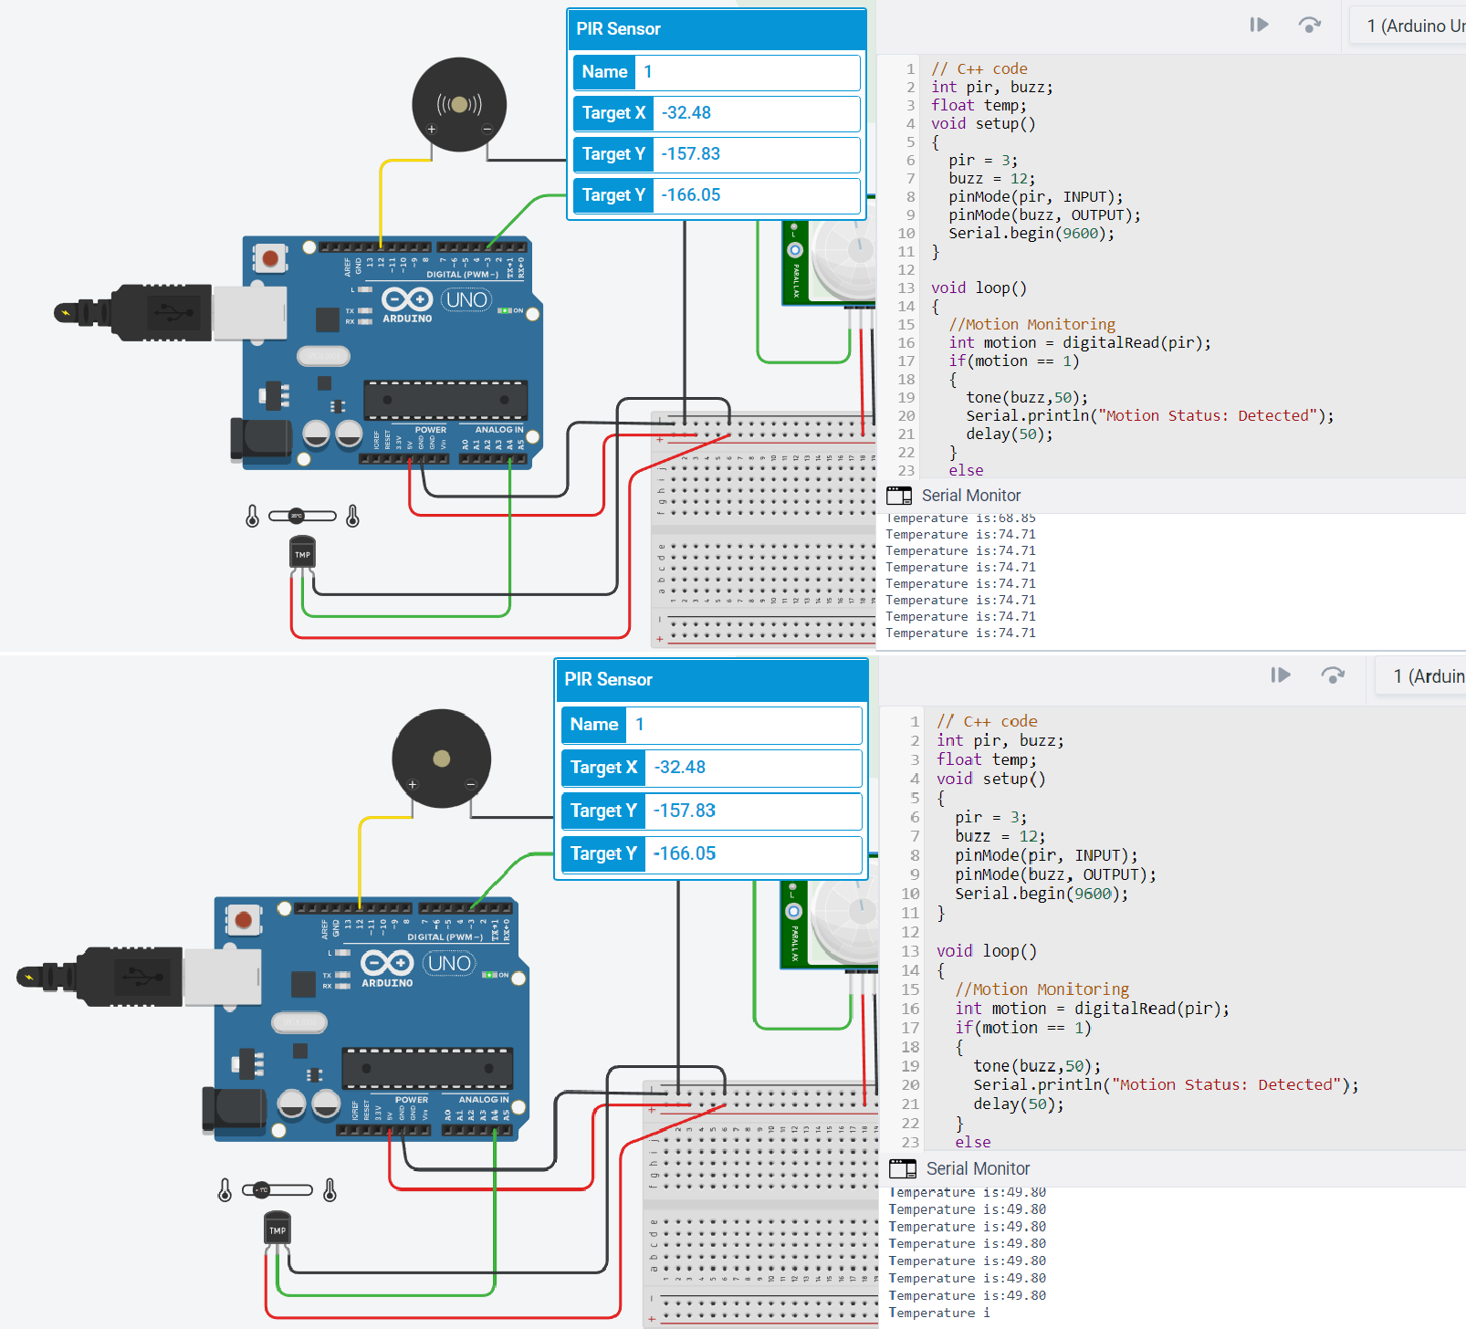

 

* 1



16 5

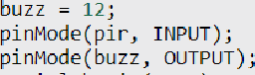

a

11 )

ee 



6eñaI Monitor



6 B + @ • -- • {@ §)|'t Simulator time: 00:00:10.543



-15L83



ee







3i fioat temp -(((data;i0za.u)*s)*lmu);

